Software Development Life Cycle (SDLC)
The Software Development Life Cycle (SDLC) is a systematic process for planning, creating, testing, deploying, and maintaining software applications. It provides a structured and standardized approach to software development that helps ensure the quality, efficiency, and effectiveness of the final product. There are several models of SDLC, each with its own set of stages and activities.
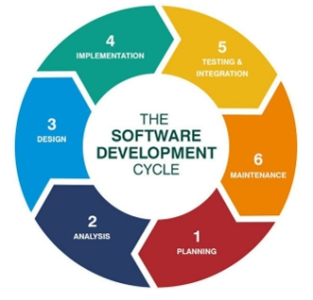
Here is a general overview of the typical stages in the SDLC:
1. Planning:
- Define the project scope, objectives, and requirements.
- Identify constraints, risks, and resources.
- Develop a project plan outlining timelines, milestones, and deliverables.
2. Feasibility Study:
- Evaluate the technical, economic, and operational feasibility of the project.
- Assess potential risks and challenges.
- Decide whether to proceed with the project or not.

3. System Design:
- Create a high-level design of the system architecture.
- Specify system components and their relationships.
- Define data structures, interfaces, and algorithms.
4. Implementation (Coding):
- Write code based on the detailed design specifications.
- Follow coding standards and best practices.
- Conduct code reviews to ensure quality and consistency.
5. Testing:
- Develop and execute test cases to ensure the software meets requirements.
- Identify and fix bugs and issues.
- Perform various testing types, such as unit testing, integration testing, system testing, and user acceptance testing.
6. Deployment:
- Release the software to the production environment.
- Ensure a smooth transition from development to production.
- Provide user training and support.
7. Maintenance and Support:
- Address issues and bugs discovered post-deployment.
- Make updates and enhancements based on user feedback.
- Provide ongoing support and maintenance.
It's important to note that these stages can be executed in a sequential manner (as in the Waterfall model) or iteratively and incrementally (as in Agile methodologies). Some common SDLC models include:
- Waterfall Model
- It is the fundamental model of the software development life cycle. This is a very simple model.
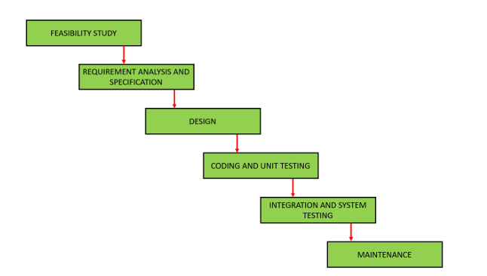
- The waterfall model is not in practice anymore, but it is the basis for all other SDLC models. Because of its simple structure, the waterfall model is easier to use and provides a tangible output.
- In the waterfall model, once a phase seems to be completed, it cannot be changed, and due to this less flexible nature, the waterfall model is not in practice anymore.

- Agile Model
- The agile model was mainly designed to adapt to changing requests quickly. The main goal of the Agile model is to facilitate quick project completion.
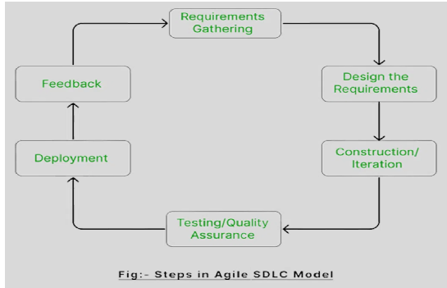
- The agile model refers to a group of development processes. These processes have some similar characteristics but also possess certain subtle differences among themselves.
- Iterative Model
- In the iterative model, each cycle results in a semi-developed but deployable version; with each cycle, some requirements are added to the software, and the final cycle results in the software with the complete requirement specification.
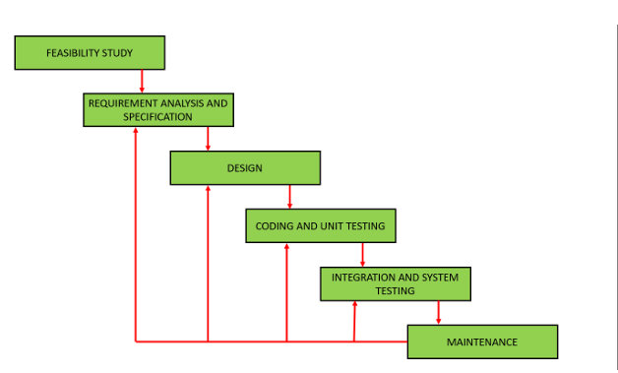
- Spiral Model
- The spiral model is one of the most crucial SDLC models that provides support for risk handling.
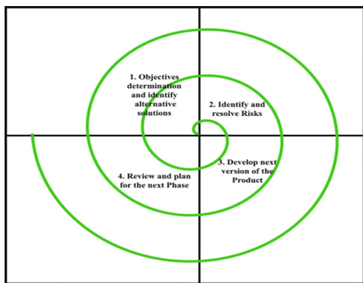
- It has various spirals in its diagrammatic representation; the number of spirals depends upon the type of project.
- Each loop in the spiral structure indicates the Phases of the Spiral model.
- V-Shaped Model
- The V-shaped model is executed in a sequential manner in V-shape. Each stage or phase of this model is integrated with a testing phase.
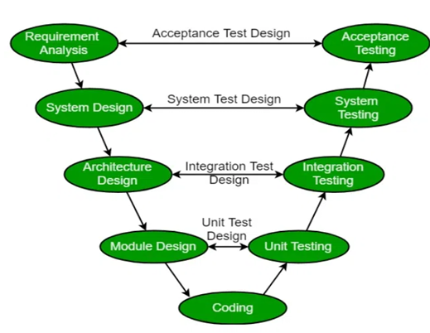
- After every development phase, a testing phase is associated with it, and the next phase will start once the previous phase is completed, i.e., development & testing. It is also known as the verification or validation model.
- Prototype
- The prototype model requires that before carrying out the development of actual software, a working prototype of the system should be built.
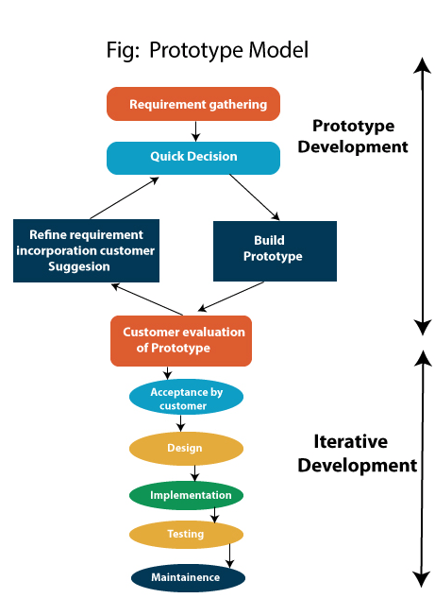
- A prototype is a toy implementation of the system.
- A prototype usually turns out to be a very crude version of the actual system, possibly exhibiting limited functional capabilities, low reliability, and inefficient performance as compared to actual software.
Project Timeline
A schedule for your entire project from inception to completion. It will break your entire project into smaller tasks and milestones, with a deadline assigned to each
Project timelines give an opportunity to:
- Organize their tasks
- Show when in the project the tasks start
- View task deadlines
- Link dependent tasks
- Break the project into phases
- Identify team members assigned to a task
You can use any tool or available software or even Excel for creating a project timeline.
Example:
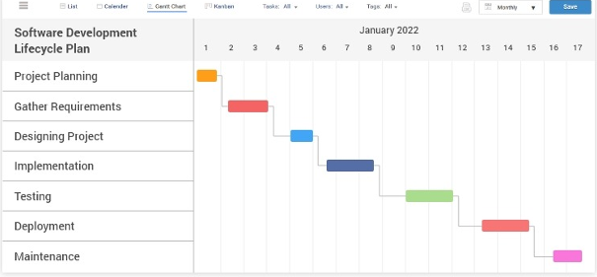
Steps to be followed:
- Research on the type of real-world projects that you can make by using Python
- Decide on your project scenario
- Select your project development model
- Decide if it will be an individual project or a group project
- Define the components to be created for your project
- Create a project timeline with roles and responsibilities
- Start development as per the timeline and your chosen project development model

Scenario:
ANALYSIS AND VISUALIZATION ON AI IMPACT ON JOBS BY 2030
Libraries used [Pandas, NumPy, Matplotlib]
Introduction
The rapid advancement and integration of artificial intelligence (AI) technologies, from machine learning to generative AI, are fundamentally reshaping the global economic landscape and redefining the future of work at an unprecedented pace.
Overview
This project analyzes how Artificial Intelligence (AI) is expected to impact different job roles by 2030. By processing a dataset that includes AI exposure, automation probability, skills, and risk categories, the project identifies the most and least affected jobs. Visualizations such as pie charts, scatter plots, and bar charts help illustrate key insights.
In this project I’m using Python IDLE-3.9 for analysis and visualization.
Objectives
The main objectives of this project are:
- To compute an AI Impact Score for each job role.
- To identify top high-risk jobs and least affected jobs.
- To visualize:
  - Job risk percentages (Pie Chart)
  - Relationship between AI impact vs automation probability (Scatter Plot)
  - Skill levels vs average AI impact (Bar Chart)
- To support stakeholders and job seekers in understanding future job trends.
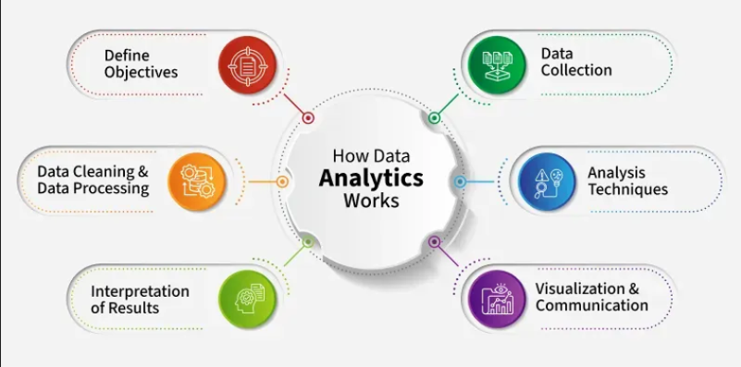
The phases followed:
• Requirement Gathering
• Data Understanding
• Data Preprocessing
• Analysis & Visualization
• Evaluation & Reporting
Dataset Description
The dataset contains the following components:
• Job Title
• AI Exposure Index
• Automation Probability (2030)
• Tech Growth Factor
• Skill_1 to Skill_10
• Risk Category

File used: DataSet.csv
STEP 1:
Exploratory Data Analysis [EDA]
This is the process by which we shall critically perform initial investigations of the data we have to discover patterns, to spot anomalies, test hypotheses and to check assumptions with the help of summary statistics and graphical representations. It is how we get to understand the data we have and gather many insights from it. It is more of making sense of the data we have before working with it.
#Importing the libraries
import pandas as pd
import numpy as np
#visualization
import matplotlib.pyplot as plt
#Importing the dataset
file = pd.read_csv("D:\\SaiJyothi\\AnudipFoundation\\Major_Project\\DataSet.csv",encoding='latin1')
#list of rows
print(file.head)
Output:
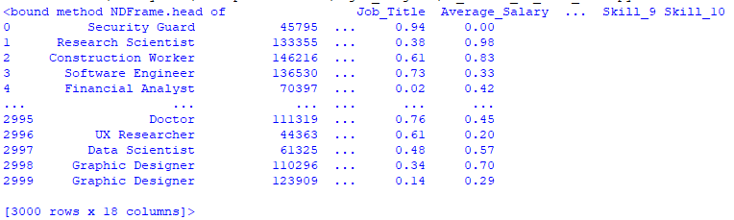
Inference:
Dataset comprises 3000 Rows and 18 columns.

Dealing With Duplicate Values
num_duplicate_rows = (file.duplicated().sum())
print(f"Number of duplicate rows: {num_duplicate_rows}")
Output:
Inference:
No duplicates rows are present in the dataset.
Dealing With Missing Values
There can be multiple reasons why certain values are missing from the data. Reasons for the missing data from the dataset affect the approach of handling missing data. So, it’s necessary to understand why the data could be missing.
Some of the reasons are listed below:
Past data might get corrupted due to improper maintenance.
Observations are not recorded for certain fields due to some reasons.
There might be a failure in recording the values due to human error.
The user has not provided the values intentionally.
#checking any null values are present in the file
total_missing_values = file.isnull().sum().sum()
print(f"\nTotal number of missing values in the dataset: {total_missing_values}")
Output:
Inference:
No null values are present in the dataset.
#Datapreprocessing Step
CREATING NEW COLUMN NAMED AS THE AI_IMPACT_SCORE
file['AI_Impact_Score'] = (file['AI_Exposure_Index'] * 0.4 +file['Automation_Probability_2030'] * 0.4 +file['Tech_Growth_Factor'] * 0.2)
#Analyzing the Job Most Affected by AI by AI_IMPACT_SCORE
unique_jobs = file.sort_values(by='AI_Impact_Score',ascending=False)\.drop_duplicates(subset=['Job_Title'], keep='first')
top_unique_job = unique_jobs[['Job_Title', 'AI_Impact_Score']].head(10)
print("MOST AI-AFFECTED UNIQUE JOB ROLE:") # Print the result
print(top_unique_job)
job_name = top_unique_job.iloc[0]['Job_Title']
impact = top_unique_job.iloc[0]['AI_Impact_Score']
print("\n Top one effected job is:", job_name)
print("Impact Score:", round(impact, 4))
Output:
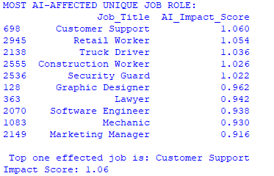
Inference:
The top most AI_AFFECTED JOB ROLE is CUSTOMER SUPPORT with IMPACT SCORE 1.06. Coming next is retail worker and truck driver.
#The least effected job by AI IMPACT BY 2030
job= unique_jobs[['Job_Title','AI_Impact_Score']].tail()
print("Lowest AI Impact jobs is:")
print(job)
Output:
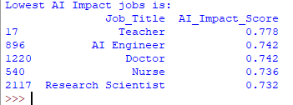

Inference:
5 safest job roles were Teacher, AI Engineer, Doctor, Nurse and Research Scientist. These are less effected jobs by AI by 2030.
Finding Answers with the Data Using Visualizations
To make it easier to understand, we are going to use matplotlib that we earlier imported to visualize our results with simple bar charts, pie chat and scatter plot. This will make it easier to answer questions that might arise from the data set.
#Percentage of Jobs by Risk Category using pie chart
risk_col = None
for c in file.columns:
if "risk" in c.lower() or "category" in c.lower():
risk_col = c
break
# If no risk column found, create a placeholder
if risk_col is None:
raise ValueError("No Risk Category column found in dataset. Please specify the column name.")
# Calculate percentage distribution
risk_counts = file[risk_col].value_counts(dropna=False)
risk_percent = (risk_counts / len(file)) * 100
# Plot pie chart
plt.figure(figsize=(6,6))
plt.pie(risk_percent, labels=risk_percent.index, autopct='%1.1f%%')
plt.title("Percentage of Jobs by Risk Category")
plt.show()

Output:
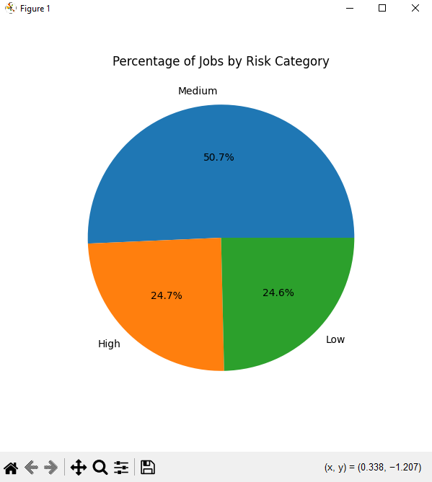
Inference:
By this we can say that Medium Risk Category Jobs which is 50.7% are high compared to High as 24.7% and Low Risk Category Jobs as 24.6%.
#Relationship between AI IMPACT SCORE VS AUTOMATION PROBABILITY USING SCATTER PLOT
aI_exposure_index=file['AI_Impact_Score']
automation_probability_2030=file['Automation_Probability_2030']
plt.scatter(aI_exposure_index, automation_probability_2030)
plt.xlabel('AI IMPACT SCORE')
plt.ylabel('AUTOMATION PROBABILITY')
plt.title('RELATIONSHIP BETWEEN AI IMPACT SCORE VS AUTOMATION PROBABILITY')
plt.show()
impact_col = "AI_Exposure_Index"

Output
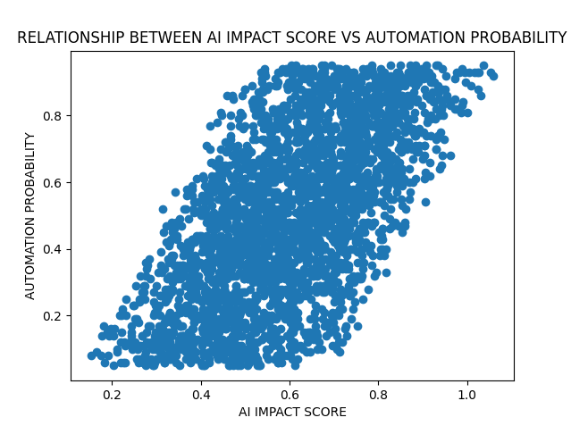
Inference:
It shows the relationship between AI Impact Score and Automation Probability. It shows the direct correlation between AI Impact Score and Automation Probability.
#SKILLS VS AVERAGE AI IMPACT USING BARCHARTS
# Identify all skill columns (Skill_1, Skill_2, ..., Skill_10)
skill_cols = [c for c in file.columns if "skill" in c.lower()]
skill_impact = {}
for col in skill_cols:
for skill in file[col].dropna().unique():
mask = (file[skill_cols] == skill).any(axis=1)
avg_val = file.loc[mask, impact_col].mean()
skill_impact[skill] = avg_val
skill_file = pd.DataFrame({
"Skill": list(skill_impact.keys()),
"Average_AI_Impact": list(skill_impact.values())
})
skill_file = skill_file.sort_values("Average_AI_Impact", ascending=False).head(15)
plt.figure(figsize=(12,6)) # Plot bar chart
plt.bar(skill_file["Skill"], skill_file["Average_AI_Impact"])
plt.xticks(rotation=90)
plt.title("Skill Levels vs Average AI Impact")
plt.xlabel("Skill")
plt.ylabel("Average AI Impact")
plt.tight_layout()
plt.show()

Output
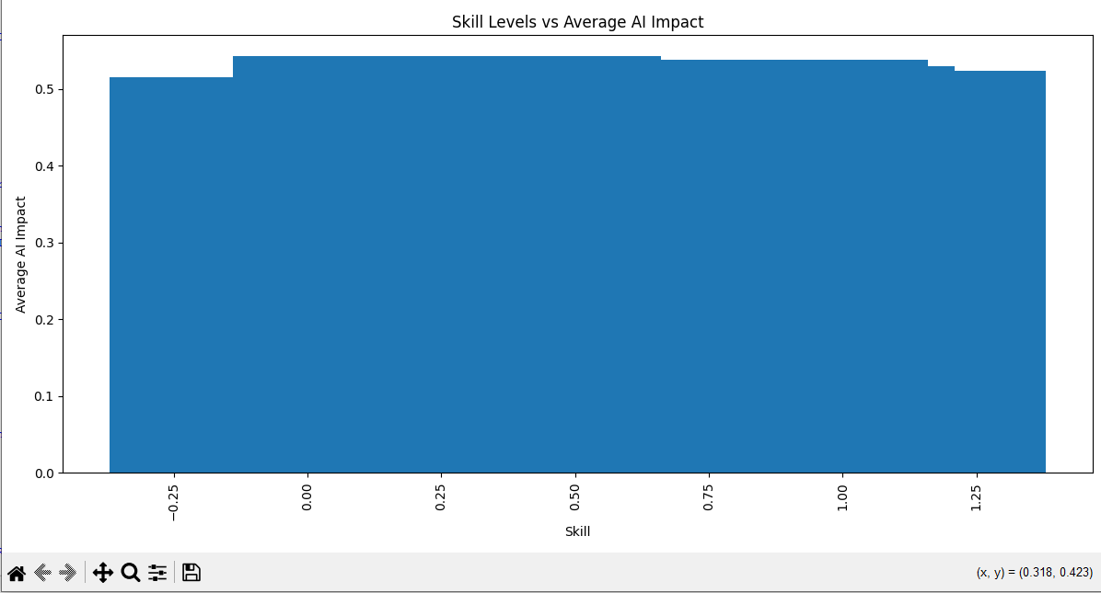
Inference:
The chart talk about the Skill Levels vs Average AI Impact. Also tell about Bar chart showing top 15 high-risk skills.

Key Insights
- Jobs with higher automation probability show significantly higher AI impact.
- Skills such as Data Processing, Machine Learning, Technical Analysis show Lowest risk.
- Several job roles still remain less affected due to human dependency.
- AI Exposure Index strongly influences the automation score.
Conclusion
AI will drastically reshape the job market by 2030. Many repetitive and predictable jobs will face high exposure, while skill-based jobs requiring creativity, emotional intelligence, and strategic decision-making will remain safer. The analysis helps individuals and organizations prepare for upcoming shifts through skill development and technology adaptation.
Future Enhancements
- Build predictive ML models to classify future job impact.
- Develop an interactive dashboard using Streamlit or Power BI.
- Integrate real-world job market data for improved accuracy.
- Include salary trends and industry-specific impact studies.

